**29th April 2016**

**YOKOHAMA and Sullivan Tire Co. to Partner with KaBOOM! on Playground Build**

Eco-friendly playground to be built June 25 in Rockland, Massachusetts

SANTA ANA, CA. – (April 29, 2016) – It’ll be playtime this summer for thousands of kids in Rockland, Massachusetts as a brand-new, eco-friendly playground is built on their behalf at Hartsuff Park come 25th June.

Yokohama Tire Corporation (YTC), the US-based subsidiary of YOKOHAMA, has identified the town as the site for the one-day build, part of its partnership commitment with KaBOOM! – the national non-profit dedicated to ensuring that all kids get a childhood filled with the balanced and active play needed to thrive.

YOKOHAMA and KaBOOM! will be joined by Sullivan Tire Co., the Rockland Park Department, Town of Rockland; Play Areas for Rockland Kids (P.A.R.K.) and approximately 200 volunteers from the community in erecting the playground.

“We’re honoured to work with Paul Sullivan and the Sullivan Tire team on this playground build, which will bring kids in Rockland a fun, safe place to play,” said Alan Holtschneider, director of marketing for YOKOHAMA. “Sullivan Tire has been a fixture in the area for more than 60 years and is known for constantly giving back to the community. This new playground will benefit kids and their families for years to come.”

YOKOHAMA, Sullivan Tire and KaBOOM! have already met with local parents and their children to help design the playground and pick out color schemes and equipment for the kids to play on, including new environmentally safe, “Cradle to Cradle”-certified playground apparatuses from Playworld Systems.

“We’re grateful that YOKOHAMA approached us with the opportunity to work with KaBOOM!,” said Paul Sullivan, Vice-President of Marketing at Sullivan Tire. “Rockland was our choice for this build because it is the town that we were founded in and have called home for over 60 years. It is a community that is very near and dear to Sullivan Tire and we welcome the chance to give back to the families in the area whenever possible. We hope this playground will be a fun fixture for kids and families of all abilities within the community for years to come.”

According to Allan Chiocca, Rockland town administrator, Rockland is happy to provide the land and Park Department resources for the new playground. “It will be a valuable addition to the recreation opportunities for children and families in Rockland.”

P.A.R.K. has been busy recruiting volunteers to help design and build the playground. “We are excited to see the project come to fruition, and look forward to seeing the community come together to build the playground,” said Janelle Hussey, P.A.R.K. president.

Holtschneider said another build with KaBOOM! will be announced in the future. YTC has a multi-channel partnership with the organization, which is also the charity recipient of the Yokohama Tire LPGA Classic in Prattville, Alabama, 5th – 8th May. All proceeds from the annual tournament will fund future playground builds to help kids get the recommended 60 minutes of daily physical activity they need to become healthy and fit.

“YOKOHAMA and Sullivan Tire are truly committed to helping us reach our goal of bringing balanced and active play to kids,” said Lysa Ratliff, KaBOOM! Vice-President, corporate partnerships. “This will be a total team effort to help the community and its children.”

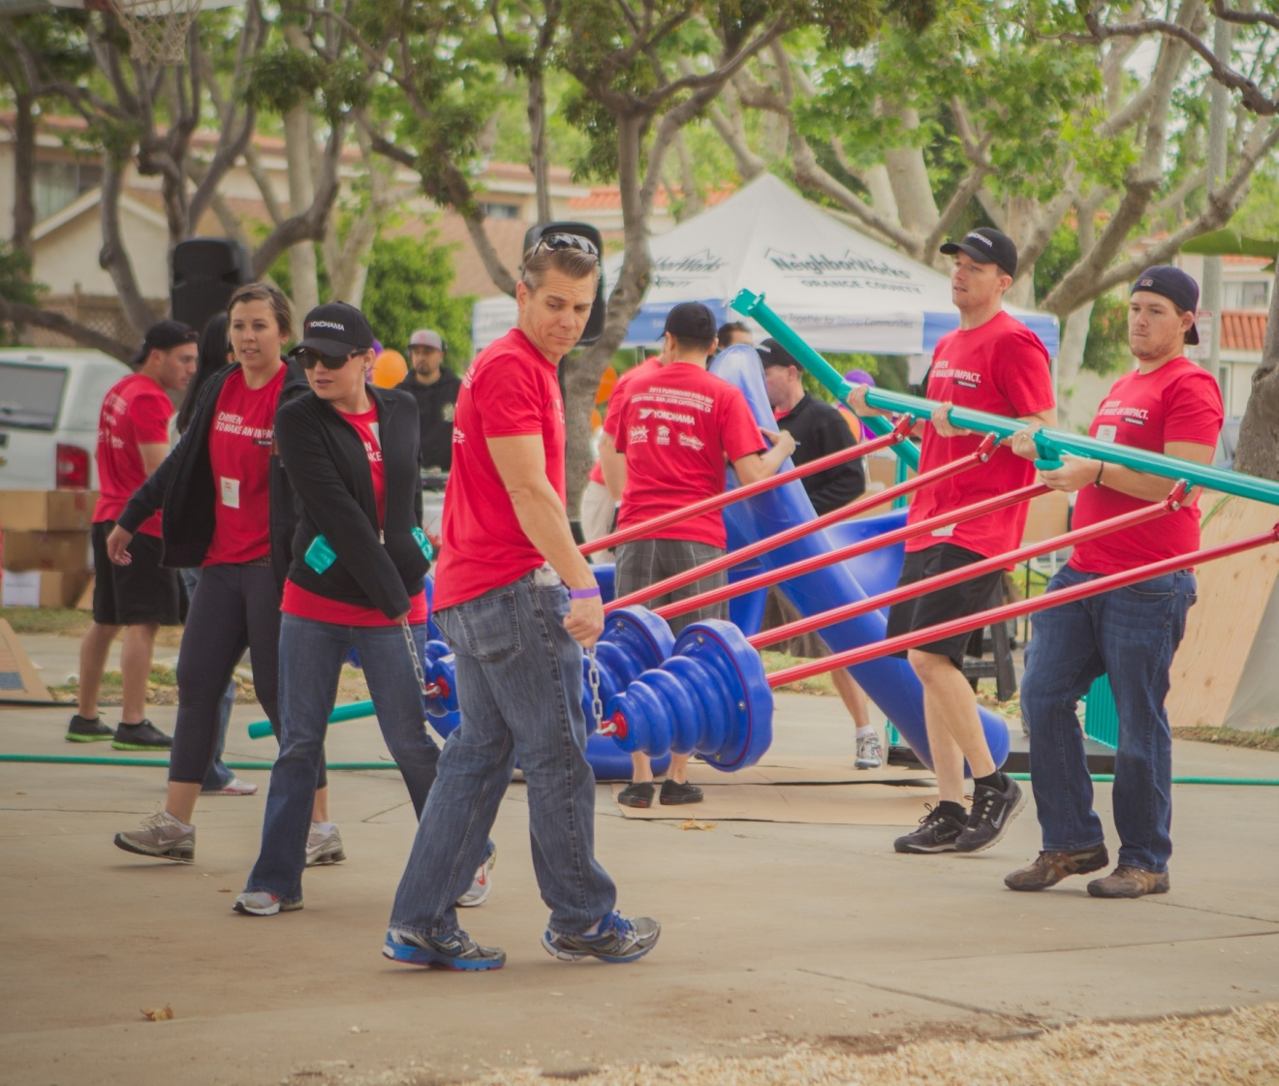

Yokohama-KaBOOM!